***FLUTe***

***TM***

***Flexible Liner Underground Technologies, LLC***

**835 Nina Way, Warminster, PA 18974**

1

**Installation Procedure**

**for**

**FLUTe Blank Liners**

*Prepared by:*

Flexible Liner Underground Technologies

835 Nina Way

Warminster, PA 18974

215-394-5760

Last Revised:

4/18/2022

Table of Contents

The FLUTe® Blank liner 3

Equipment Needed 4

Installation Procedure 4

FLUTe Summary and Comments 7

# The FLUTe® Blank liner

**Method:** The FLUTe blank liner is a tubular urethane coated nylon liner which is normally everted into place as shown in Fig. 1. It is easier to understand the everting process if one starts with the lined hole of Fig. 1a. The excess head inside the liner, above the water table in the formation, forces the liner out against the hole wall and forms a continuous seal of the hole much like a continuous packer. By pulling up on the tether shown in the figure, the liner inverts and can be peeled from the hole wall as the tether and then the liner are wound on a reel at the surface (Fig. 1b-1c).

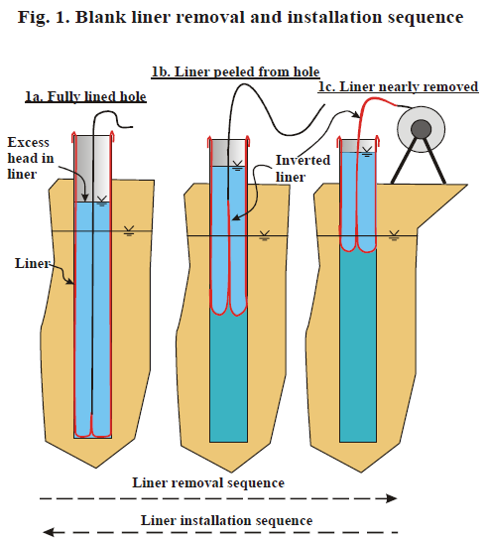

The installation procedure for the blank liner is the reverse procedure (Fig. 1c-1a). Illustrated in Fig. 1c, the inside-out liner is pulled from the reel and clamped to the top of the casing. The liner is pushed down into the casing to form an annular pocket. Water is added to the interior of the liner forcing the liner against the hole wall and down the hole, pulling the liner from the reel. As the liner “everts” down the hole (the reverse of peeling it out of the hole), the water in the borehole is forced into the formation. The liner will continue to descend into the borehole until it reaches the bottom of the hole or until all flow paths in the borehole are sealed by the liner and the water beneath the liner cannot be forced into the formation, shown in Figure 1a.

**Uses:** The blank liner is a convenient method for sealing the borehole to

prevent contaminant transport in the hole. Many geophysical measurements can be performed

inside the liner, with the liner sealing the hole. Those measurements are: gamma and gamma-gamma logs, induction coupled electric log (resistivity), sonic logs of several kinds, temperature logs, radar measurements, and neutron moisture logs in the vadose zone. A very attractive use of the blank liner is the measurement (i.e., location and flow rate) of all significant flow paths in the borehole while the liner is descending into position. For details on this *Hydraulic Conductivity* *Profiling Technique,* visit www.flut.com, or call us at 215-394-5760.

# Equipment Needed

* Steel Reel Stands and Axle
* Poly Tubing, Trimmie Pipe (1/2”, ¾”)
* Band Clamp
* Tether Bar
* Water Source
* Venturi Vacuum Pump
* Compressed Air Source
* Green Machine (Optional)

# Installation Procedure

1. Tag depth of hole and static water level.
2. Setup liner by sliding an axle through the liner reel and place it onto reel stands.
3. Remove plastic wrap, bubble wrap, and documentation from liner**. Do not use knives or sharp objects to open liner**. Keep documentation for notes.
4. Remove poly tubing from the reel, slightly scallop the bottom end of the poly (approximately 5-10 feet up from the bottom).
   1. For blank liner installations used to seal open boreholes, the poly tubing will act as a vent tube during liner eversion from ground surface to the water table. This vent tube will be a migration pathway for air to escape from the open borehole above the water table and will prevent a “balloon” from forming inside the liner during the initial installation.
   2. The vent tube should sit a couple inches above static water level. It is best to measure how far it is placed downhole by measuring it beforehand on the ground. To know that it’s sitting at or slightly above the water table, it may be useful to force air by blowing into the poly to hear bubbling. **Do not drop poly downhole; firmly secure it to the reel stand or casing.**
   3. The same poly tubing may also act as a pump tube when used for NAPL/FACT liner installations in which the liner needs to evert and seal the entire length of the borehole, whether the borehole is transmissive or not.
5. Place liner reel over top of the casing so that the liner aligns center over the casing.
6. Depending on if the liner will later be used for a transmissivity profiling test of the borehole, the length of extension on the liner may need to be left as is during the installation process.
   1. If a profiling test is to be performed, the extension will be used to help create a higher head above static water level in order to have the appropriate driving pressure during the liner’s eversion.
   2. If the hole is not to be profiled, the extension on the liner may be trimmed to align the ground surface (G.S) mark on the liner with ground surface of the well.

**For Vault Installations**

1. If the casing is in a vault: measure down to the top of the casing from G.S and make note of the length.
2. Measure this same distance from the ground surface mark shown on the liner towards the direction of the reel and mark a line with a sharpie. This will allow the G.S mark on the liner to match ground surface, and the new marking will align with the top of casing.
3. **Do not cut on your original line.** Using scissors, cut straight across the liner at a place in between the G.S line and the new marking as this area will be used to secure the liner to the top of the casing (It is best to have a ~2” overlap). Do not cut the bubbler tube located within the yellow weld strip.
4. Cut a small (2”) vertical slit down along the seam of the liner from the top. This slit will go around the vent tube when the liner is folded over the casing. It is best to match the seam of the liner with the same side of the vent tube, the vent tube may need to be moved to align correctly with the slit.
5. Cut a 0.5-1ft vertical slit down the thin yellow strip the covers the bubbler. Do not cut all the way through both sides of the yellow lining.
6. Pre-evert the liner to a length of 5-6 ft and lower into the casing. Pre-eversion is required as the liner needs to overcome the minimum pressure to initially displace downhole.
7. Align the new marking with the top of the casing, fold over, and clamp liner to the top of the casing using the provided band clamp. It may help to secure the liner first with electrical tape to make putting the band clamp on easier.

**For Casing Stickup Installations**

1. If the casing sticks up above ground surface measure the height from G.S to top of casing and make note of the length.
2. Measure this same distance from the ground surface mark on the liner towards the direction of the end of the liner away from the reel and mark a line with a sharpie. This will allow the G.S mark on the liner to match ground surface, and the new marking will align with the top of the stick up.
3. Using scissors, cut straight across the liner at a place 2-3” above the new marking as this area will be used to secure the liner to the top of the casing with enough overlap. Do not cut the bubbler tube located within the yellow weld strip.
4. Repeat steps 10 through 12.

**Continued Blank Installation**

1. Once the liner is pre-everted and clamped, place the water source into the top of the casing and begin filling the liner, keep the liner from moving downhole for the initial pre-eversion length and fill to top. This will give the liner enough head to evert down to the water table.
2. The water source may be shut off during the liner’s eversion down to the water table. Too much initial head can cause the liner to evert at a fast rate and fly downhole to the water table. Allow enough tension on the liner to ease it down to the water table.
3. As the liner reaches the water table, there should be a noticeable change in liner back tension. At this point, fill the liner so you have roughly 10’ above the static water level of the hole, and allow the liner to evert naturally. Keep the water level inside the liner at roughly 10’ above the static water level of the hole for the entirety of the installation.
4. The rate at which the liner descends is based on the flow beneath the liner in the open borehole.
5. A venturi vacuum pump may be used to remove air from the inside of the inverted part of the liner so that a balloon does not form inside the liner itself. The venturi will attach to the clear vent tube that is spooled on the reel with the tether and will connect to an air hose.
6. As the liner descends, eversion point (E.P) markings will show at intervals on the liner, representing the depth at which the bottom of the liner is currently at.
7. At the halfway point there will be a knot attaching the liner to the tether, this is the bottom of the liner that will evert down to the bottom of the borehole. The tether will run the length of the entire borehole up to the surface. Disconnect the venturi as it will no longer be useful once the vent tube goes downhole.
8. As the liner slows with depth the tether line will be tied off to the tether bar to keep tension on the liner and to keep the system in place.
9. Once the liner stops or reaches a velocity of 20 inches a minute or less, tie an overhand knot in the tether line (shown below), place the tether bar through the knot, and rest on top of the casing. There should be little to no slack on the tether line once the liner is tied off.

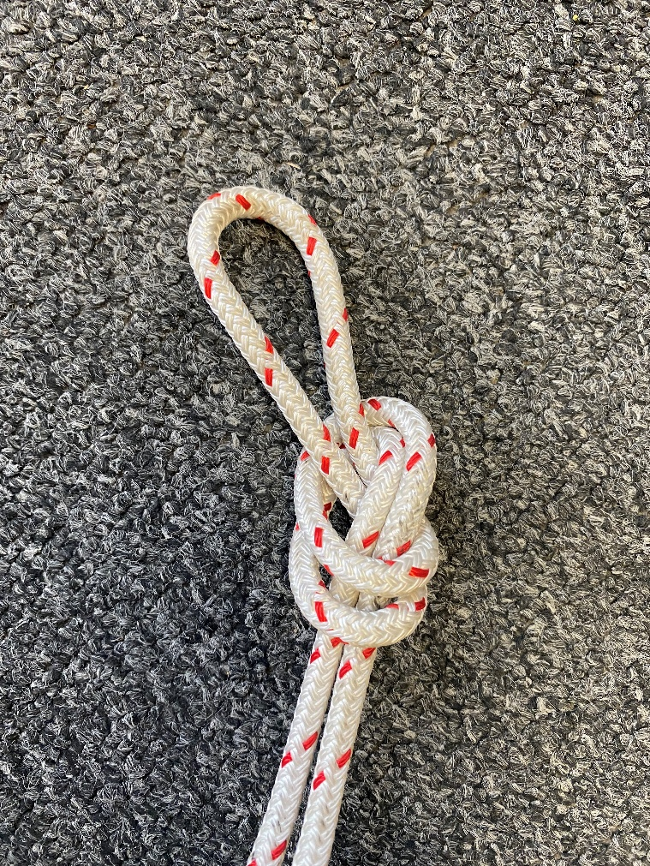

1. Top off the water in the liner as it may continue to dilate over time. The water level in the liner will slowly drop until the liner is fully dilated.
2. The installation process is complete once the water level in the liner remains static. Note the amount of water used during installation.

Any questions call: Warminster Shop 215-394-5760

Albuquerque Shop 505-883-4032

# FLUTe Summary and Comments

For additional information regarding FLUTe Blank Liner Installations, please contact the following:

**Carl Keller**

Principle Scientist

Flexible Liner Underground Technologies

1091 State Rd 68

Velarde, NM 87582

(P) 505-852-0128 / (M) 505-930-1154 [carl@flut.com](mailto:carl@flut.com)

**Ian Sharp**

Chief of Fielding Operations

Flexible Liner Underground Technologies

2412 Princeton Drive NE Suite B

Albuquerque, NM 87107

(P) 505-883-4032 / (M) 505-720-8429 [ian@flut.com](mailto:ian@flut.com)

**Daniel Schramm**

East Coast Field Manager

Flexible Liner Underground Technologies

835 Nina Way

Warminster, PA 18974

(P) 215-394-5760 / (M) 215-847-0049 [dan@flut.com](mailto:dan@flut.com)